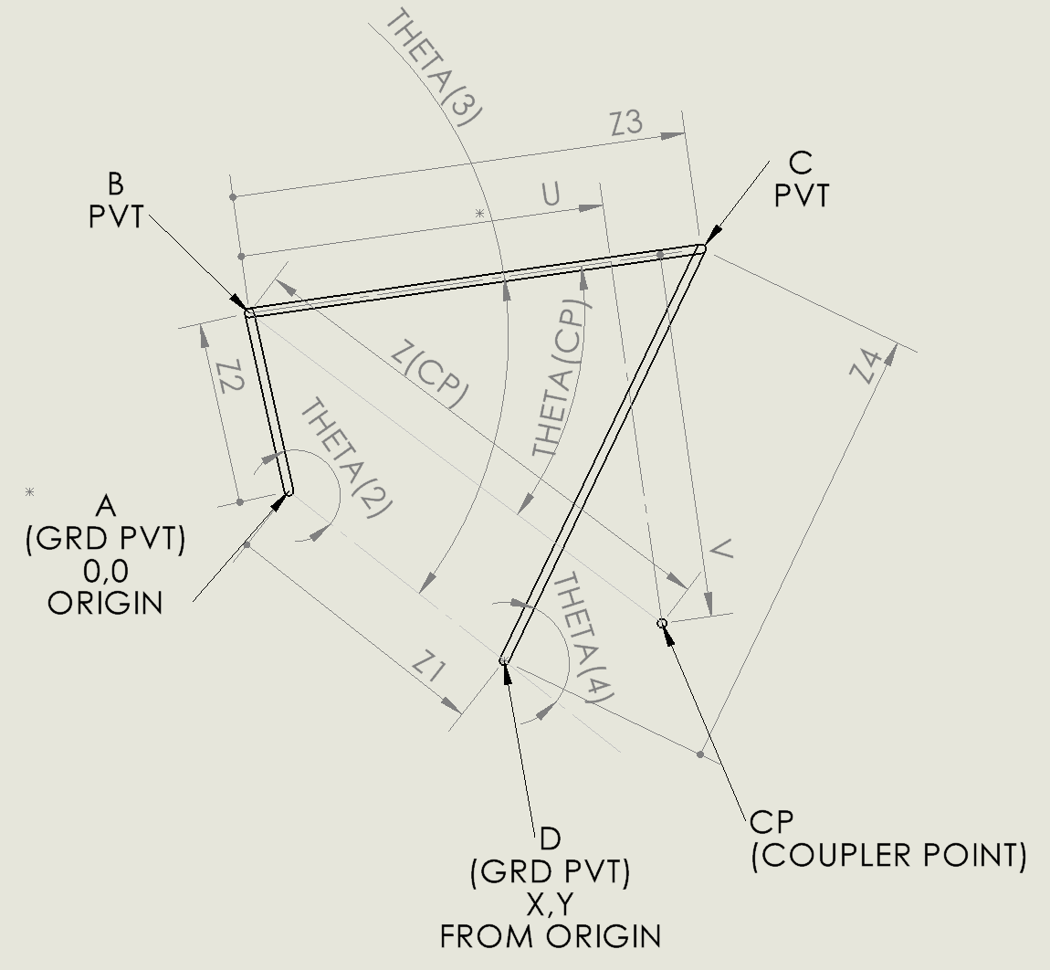
Vector loop as show. Z2 + Z3 – Z4 = Z1
Z1, Z2, Z3, Z4 given magnitudes.
Pivot A and D positions given. (Pivot A defined at 0,0. Pivot B at X,Y) Z1 is the distance between ground pivots A and D
Z2 is the driving crank.
Z3 is the coupler link.
Z4 is the rocker link.
THETA(2) changes at a constant rotational velocity OMEGA(2)
CP is defined as the coupler point location along the coupler link from pivot B distance U, and orthogonal to this U vector by length V. U and V are given.
Z(CP) magnitude is defines as (U^2 + V^2)^.5
THETA(CP) is tan(V/U) oriented CCW from direction Z3 starting for pivot B.
Track THETA angles relative to the Z1, with Z1 providing the direction defined as THETA = 0
Calculate as output:
CP (coupler point) information:
minimum velocity at position it occurs,
maximum velocity at position it occurs,
minimum acceleration at position it occurs,
maximum acceleration at position it occurs,
minimum jerk at position it occurs,
maximum jerk at position it occurs,
Positions are based on ground pivot A being 0,0 with x axis define point right and horizontal

Here are the equations for Z1, Z2, Z3, Z4 closure analysis. The CP position and kinematics are applied relative to pivot B and Z3 in order the provide the requested CP related results. Please include the derivative and the acceleration equation for the jerk values requested at CP coupler point.

